**Analyzing Road Safety in the UK**

**Business problem:**

**The UK Department of Transport provides open datasets on road safety and casualties, and one can**

**use these datasets to analyze how safe the roads in the UK are. This project will help you answer a**

**few questions using their 2015 dataset.**

**The dataset has 3 tables i.e Accident, vehicle, Vehicle_type**

**Approach/Project Idea**

**Use aggregate functions in SQL and Python to answer the following sample questions:**

**1. Evaluate the median severity value of accidents caused by various Motorcycles.**

**2. Evaluate Accident Severity and Total Accidents per Vehicle Type**

**3. Calculate the Average Severity by vehicle type.**

**4. Calculate the Average Severity and Total Accidents by Motorcycle.**

**Github source code link:**

[**https://lnkd.in/dbEAKY2G**](https://lnkd.in/dbEAKY2G)

**#Creating Database Road_Safety:**

**create database if not exists Road_Safety;**

**use Road_Safety;**

**#Creating Table Accident_2015:**

**create table if not exists Accident_2015(**

**Accident_Index varchar(200),**

**Location_Easting_OSGR double,**

**Location_Northing_OSGR double,**

**Longitude double,**

**Latitude double,**

**Police_Force int,**

**Accident_Severity int,**

**Number_of_Vehicles int,**

**Number_of_Casualties int,**

**`Date` varchar(200),**

**Day_of_Week int,**

**`Time` time,**

**`Local_Authority_(District)` int,**

**`Local_Authority_(Highway)` varchar(200),**

**1st_Road_Class int,**

**1st_Road_Number int,**

**Road_Type int,**

**Speed_limit int,**

**Junction_Detail int,**

**Junction_Control int,**

**2nd_Road_Class int,**

**2nd_Road_Number int,**

**`Pedestrian_Crossing-Human_Control` int,**

**`Pedestrian_Crossing-Physical_Facilities` int,**

**Light_Conditions int,**

**Weather_Conditions int,**

**Road_Surface_Conditions int,**

**Special_Conditions_at_Site int,**

**Carriageway_Hazards int,**

**Urban_or_Rural_Area int,**

**Did_Police_Officer_Attend_Scene_of_Accident int,**

**LSOA_of_Accident_Location varchar(200)**

**);**

**select * from accident_2015;**

**#Bulk Upload in Table Accident_2015 from Accident_2015.csv file:**

**Load Data infile**

**'E:/DataAnalyst Ineuron/SQL_SUDHANSHU/SQL_ASSIGNMENTS/Anand Jha Assignement/Accident_2015.csv'**

**into table accident_2015**

**Fields terminated by ','**

**enclosed by '"'**

**Lines terminated by '\n'**

**ignore 1 rows;**

**select COUNT(*) from accident_2015;**

**#Creating Table Vehicle_2015:**

**create table vehicle_2015(**

**Accident_Index varchar(200),**

**Vehicle_Reference int,**

**Vehicle_Type int,**

**Towing_and_Articulation int,**

**Vehicle_Manoeuvre int,**

**`Vehicle_Location-Restricted_Lane` int,**

**Junction_Location int,**

**Skidding_and_Overturning int,**

**Hit_Object_in_Carriageway int,**

**Vehicle_Leaving_Carriageway int,**

**Hit_Object_off_Carriageway int,**

**1st_Point_of_Impact int,**

**Was_Vehicle_Left_Hand_Drive int,**

**Journey_Purpose_of_Driver int,**

**Sex_of_Driver int,**

**Age_of_Driver int,**

**Age_Band_of_Driver int,**

**`Engine_Capacity_(CC)` int,**

**Propulsion_Code int,**

**Age_of_Vehicle int,**

**Driver_IMD_Decile int,**

**Driver_Home_Area_Type int,**

**Vehicle_IMD_Decile int**

**);**

**select * from vehicle_2015;**

**#Bulk Upload in Table Vehicle_2015 from Vehicle_2015.csv file:**

**Load Data infile**

**'E:/DataAnalyst Ineuron/SQL_SUDHANSHU/SQL_ASSIGNMENTS/Anand Jha Assignement/Vehicle_2015.csv'**

**into table vehicle_2015**

**Fields terminated by ','**

**enclosed by '"'**

**Lines terminated by '\n'**

**ignore 1 rows;**

**select count(*) from vehicle_2015;**

**#Creating Table Vehicle_types:**

**create table vehicle_types(**

**`code` double,**

**label varchar(200));**

**#Load Data in Vehicle_types from Vehicle_types.csv:**

**Load Data infile**

**'E:/DataAnalyst Ineuron/SQL_SUDHANSHU/SQL_ASSIGNMENTS/Anand Jha Assignement/Vehicle_types.csv'**

**into table vehicle_types**

**Fields terminated by ','**

**enclosed by '"'**

**Lines terminated by '\n'**

**ignore 1 rows;**

**select * from vehicle_types;**

**#2. Evaluate the median severity value of accidents caused by various Motorcycles:**

**with answer1 as(select avg(Accident_Severity) as Average_Severity ,Vehicle_type from accident_2015 inner join vehicle_2015 on accident_2015.accident_index=vehicle_2015.accident_index group by vehicle_type order by vehicle_type) select Average_Severity,Vehicle_type,label as Vehicle_Type_Name from answer1 inner join vehicle_types on answer1.Vehicle_type=vehicle_types.`code` where label like '%otorcycle%';**

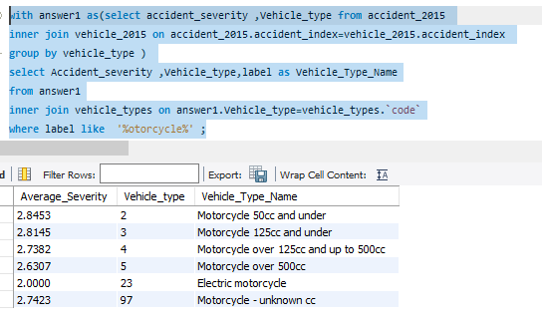

**#2. Evaluate Accident Severity and Total Accidents per Vehicle Type:**

**#(i)Accident Severity per Vehicle Type:**

**with answer2 as(select Accident_Severity,Vehicle_type from accident_2015 inner join vehicle_2015 on accident_2015.accident_index=vehicle_2015.accident_index group by vehicle_type order by vehicle_type) select Accident_Severity,Vehicle_type,label as Vehicle_Type_Name from answer2 inner join vehicle_types on answer2.Vehicle_type=vehicle_types.`code`;**

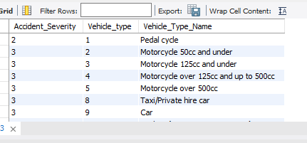

**#(ii)Total Accidents per Vehicle Type:**

**with answer2b as(select sum(Number_of_casualties) as Total_Accidents,Vehicle_type from accident_2015 inner join vehicle_2015 on accident_2015.accident_index=vehicle_2015.accident_index group by vehicle_type order by Total_Accidents) select Total_Accidents,Vehicle_type,label as Vehicle_Type_Name from answer2b inner join vehicle_types on answer2b.Vehicle_type=vehicle_types.`code`;**

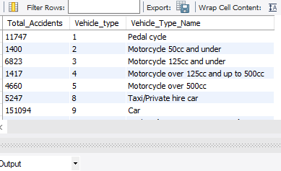

**#3. Calculate the Average Severity by Vehicle Type:**

**with answer3 as(select avg(Accident_Severity) as Average_Severity ,Vehicle_type from accident_2015 inner join vehicle_2015 on accident_2015.accident_index=vehicle_2015.accident_index group by vehicle_type order by vehicle_type) select Average_Severity,Vehicle_type,label as Vehicle_Type_Name from answer3 inner join vehicle_types on answer3.Vehicle_type=vehicle_types.`code` order by Average_Severity;**

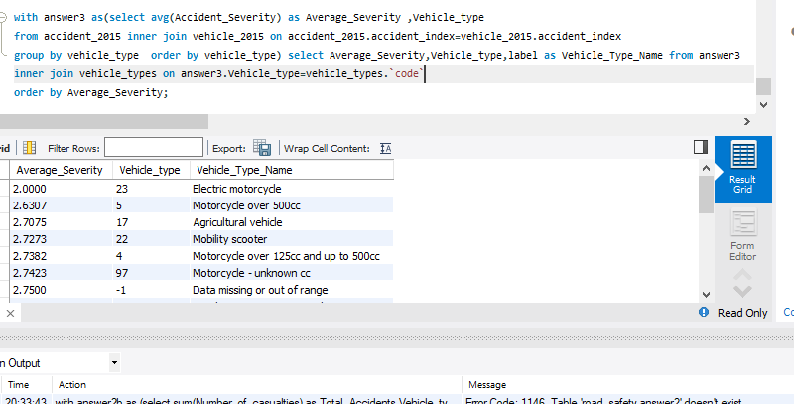

**#4. Calculate the Average Severity and Total Accidents by Motorcycle:**

**#(i). Average Severity by Motorcycle:**

**with answer4b as(select accident_severity ,Vehicle_type from accident_2015 inner join vehicle_2015 on accident_2015.accident_index=vehicle_2015.accident_index group by vehicle_type ) select avg(accident_severity) as Average_Severity_By_Motorcycle from answer4b inner join vehicle_types on answer4b.Vehicle_type=vehicle_types.`code` where vehicle_type in (2,3,4,5,23,97) ;**

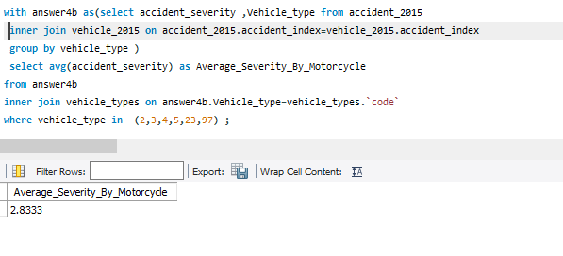

**#(ii). Total Accidents by Motorcycle:**

**with answer2b as(select sum(Number_of_casualties) as Total_Accidents,Vehicle_type from accident_2015 inner join vehicle_2015 on accident_2015.accident_index=vehicle_2015.accident_index group by vehicle_type order by Total_Accidents) select sum(Total_Accidents) as Total_Accidents_By_Motorcycle from answer2b inner join vehicle_types on answer2b.Vehicle_type=vehicle_types.`code` where vehicle_type in (2,3,4,5,23,97) ;**

